BASIC DETAILS
07549--S N TRUSTS CENTRAL SCHOOL SHORANUR PALAKKAD KL
Dated : 14/09/2018
SCHOOL NAME | S N TRUSTS CENTRAL SCHOOL SHORANUR PALAKKAD KL | SCHOOL CODE | 07549
ADDRESS | SREE NARAYANA TRUSTS CENTRAL SCHOOL,SHORANUR,PALAKKAD | AFFILIATION CODE | 930426
PRINCIPAL | MRS KANAKALATHA A | PRINCIPAL'S CONTACT NUMBER | 9605180270
PRINCIPAL'S EMAIL ID | lathahari2018@gmail.com | PRINCIPAL'S RETIREMENT DATE | 31/03/2026
SCHOOL'S CONTACT NUMBER | 0466-2223387 | SCHOOL'S EMAIL ID | sntcentralschool@gmail.com
SCHOOL'S WEBSITE | www.sntcsshoranur.org | SCHOOL'S FAX NUMBER | 04742764787
LANDMARK NEAR SCHOOL | POST OFFICE | YEAR OF ESTABLISHMENT | 2000
AFFILIATION VALIDITY | 2003 TO 2018 | AFFILIATION STATUS | PROVISIONAL
NAME OF THE TRUST/SOCIETY/COMPANY REGISTERED WITH | THE SREE NARAYANA TRUSTS KOLLAM | REGISTRATION DATE | 26/08/1952
SOCIETY REGISTRATION NUMBER | 4232 | REGISTRATION VALIDITY | PERMANENT REGISTRATION
NOC ISSUING AUTHORITY | GOVERNMENT OF KERALA | NOC ISSUING DATE | 26/03/2002
NO OBJECTION CERTIFICATE | VIEW | NON PROPRIETY CHARACTER AFFIDAVIT/NON PROFIT COMPANY AFFIDAVIT | VIEW

FACULTY DETAILS
07549--S N TRUSTS CENTRAL SCHOOL SHORANUR PALAKKAD KL
Dated : 14/09/2018
TOTAL NUMBER OF TEACHERS (ALL CLASSES) | 34 | NUMBER OF PGTs | 3
NUMBER OF TGTs | 12 | NUMBER OF PRTs | 18
NUMBER OF PETs | 1 | OTHER NON-TEACHING STAFF | 25
NUMBER OF MANDATORY TRAINING QUALIFIED TEACHERS | 34 | NUMBER OF TRAININGS ATTENDED BY FACULTY SINCE LAST YEAR | 8

STUDENT DETAILS
07549--S N TRUSTS CENTRAL SCHOOL SHORANUR PALAKKAD KL
Dated : 14/09/2018
CLASS | TOTAL NUMBER OF SECTIONS | TOTAL NUMBER OF INTAKE | TOTAL NUMBER OF STUDENTS
1 | 2 | 66 | 66
2 | 2 | 74 | 74
3 | 2 | 63 | 63
4 | 2 | 79 | 79
5 | 2 | 57 | 57
6 | 2 | 65 | 65
7 | 2 | 59 | 59
8 | 1 | 41 | 41
9 | 1 | 29 | 29
10 | 2 | 47 | 47
11 | 1 | 10 | 10
12 | 1 | 15 | 15

ACADEMIC DETAILS
07549--S N TRUSTS CENTRAL SCHOOL SHORANUR PALAKKAD KL
Dated : 14/09/2018
SUBJECTS OFFERED FOR CLASS 10 | SUBJECTS OFFERED FOR CLASS 12
012---MALAYALAM  041---MATHEMATICS  085---HINDI COURSE-B  086---SCIENCE  087---SOCIAL SCIENCE  101---ENGLISH COMM.  531---LITERARY AND CREATIVE SKILLS  532---SCIENCE SKILLS  541---SPORTS/INDIGENOUS SPORTS  546---YOGA | 030---ECONOMICS  041---MATHEMATICS  043---CHEMISTRY  044---BIOLOGY  054---BUSINESS STUDIES  055---ACCOUNTANCY  065---INFORMATICS PRAC.  083---COMPUTER SCIENCE  301---ENGLISH CORE  500---WORK EXPERIENCE  502---PHY & HEALTH EDUCA  503---GENERAL STUDIES  042---PHYSICS

INFRASTRUCTURE DETAILS
07549--S N TRUSTS CENTRAL SCHOOL SHORANUR PALAKKAD KL
Dated : 14/09/2018
TOTAL NUMBER OF SITES OF SCHOOL | 2 | TOTAL NUMBER OF BUILDING BLOCKS | 2
TOTAL AREA OF SCHOOL IN SQUARE METRES | 4008 | TOTAL NUMBER OF PLAYGROUNDS | 2
TOTAL AREA OF PLAYGROUND IN SQUARE METRES | 5279 | TOTAL NUMBER OF ROOMS | 40
TOTAL NUMBER OF SMALL-SIZED ROOMS | 12 | TOTAL NUMBER OF MEDIUM-SIZED ROOMS | 22
TOTAL NUMBER OF LARGE-SIZED ROOMS | 6 | TOTAL NUMBER OF MALE REST ROOM | 1
TOTAL NUMBER OF FEMALE REST ROOM | 4 | NUMBER OF GIRLS' TOILET | 35
NUMBER OF BOYS' TOILET | 42 | NUMBER OF TOILETS FOR DIFFERENTLY ABLED PERSONS | 0
NUMBER OF WASHROOMS FOR FEMALE STAFF | 5 | NUMBER OF WASHROOMS FOR MALE STAFF | 2
TOTAL NUMBER OF LIBRARIES | 1 | NUMBER OF LABORATORIES | 4
TOTAL NUMBER OF STUDENT CANTEENS | 0 | TOTAL NUMBER OF STAFF CANTEENS | 0
NUMBER OF WATER PURIFIERS/ROs | 2 | NUMBER OF AUDITORIUMS | 1
NUMBER OF LIFTS/ELEVATORS | 0 | NUMBER OF DIGITAL CLASSROOMS | 28
DOES THE SCHOOL HAS HOSTEL FACILITY | NO | DOES THE SCHOOL HAS GUARDS EMPLOYED FOR SAFETY | YES
DOES THE SCHOOL HAS FIRE EXTINGUISHERS | YES | DOES THE SCHOOL HAS SPRINKLERS | YES
DOES THE SCHOOL HAS CCTV CAMERAS INSTALLED? | YES | IS THE SCHOOL EXAMINATION CENTER OF CBSE? | NO
TOTAL NUMBER OF COMPUTERS IN ALL COMPUTER LAB | 13 | DOES THE SCHOOL HAS WEB SERVERS | YES
DOES THE SCHOOL HAS A BOUNDARY WALL? | YES | IS YOUR SCHOOL BARRIER FREE/ HAS RAMPS? | NO
DOES THE SCHOOL HAS CLINIC FACILITY? | NO | DOES THE SCHOOL HAS A STRONG ROOM? | YES
DOES THE SCHOOL HAS A GYMNASIUM? | NO | IS YOUR SCHOOL WI-FI ENABLED? | YES
PROVISION OF WEB BASED LEARNING PROGRAMS? | YES | DOES THE SCHOOL HAS FIRE ALARMS? | NO
DOES THE SCHOOL HAS SPORTS FACILITY? | YES | DOES THE SCHOOL HAS INDOOR GAMES FACILITY? | YES
DOES THE SCHOOL HAS A SWIMMING POOL? | NO | DOES THE SCHOOL HAS DANCE/MUSIC FACILITY? | YES
TOTAL NUMBER OF BUSES OWNED | 9 | TOTAL NUMBER OF BUSES HIRED | 0
TOTAL NUMBER OF VANS/MATADORS | 0 | TOTAL NUMBER OF DRIVERS | 9
NUMBER OF FEMALE ATTENDANTS FOR BUS DUTY | 9 | NUMBER OF ACTIVITY ROOMS | 3
NAME OF TRANSPORT COORDINATOR | VINOD R | TRANSPORT COORDINATOR CONTACT | 8301914501
BUILDING SAFETY CERTIFICATE | VIEW | TRANSPORT SAFETY CERTIFICATE | VIEW

LOCATION DETAILS
07549--S N TRUSTS CENTRAL SCHOOL SHORANUR PALAKKAD KL
Dated : 14/09/2018
NEAREST NATIONALISED BANK | SBI | DISTANCE OF BANK FROM SCHOOL IN KM | 3
NEAREST BUS STATION | SHORANUR | DISTANCE OF BUS TERMINAL FROM SCHOOL IN KM | 3
NEAREST RAILWAY STATION | SHORANUR | DISTANCE OF RAILWAY STATION FROM SCHOOL IN KM | 4
NEAREST AIRPORT | COCHIN INTERNATIONAL AIRPORT | DISTANCE OF AIRPORT FROM SCHOOL IN KM | 101
NEAREST HOSPITAL | PRIMARY HEALTH CENTRE SHORANUR | DISTANCE OF HOSPITAL FROM SCHOOL IN KM | 3
NEAREST POLICE STATION | SHORANUR | DISTANCE OF POLICE STATION FROM SCHOOL IN KM | 3
NEAREST METRO STATION |  | DISTANCE OF METRO FROM SCHOOL IN KM

OTHER VITAL INFORMATION
07549--S N TRUSTS CENTRAL SCHOOL SHORANUR PALAKKAD KL
Dated : 14/09/2018
10th BOARD PASS PERCENTAGE (2014/2015/2016) | 100/100/100 | 12th BOARD PASS PERCENTAGE (2014/2015/2016) | 100/100/100
NAME OF WELLNESS/ACTIVITY TEACHER | YES | NAME OF GRIEVANCE/COMPLAINT REDRESSAL OFFICER | V P CHANDRAN
CONTACT NUMBER OF GRIEVANCE/COMPLAINT REDRESSAL OFFICER | 9349171708 | EMAIL ID OF GRIEVANCE/COMPLAINT REDRESSAL OFFICER | vinuuleela@gmail.com
NAME OF HEAD OF SEXUAL HARASSMENT COMMITTEE | PREETHA R MENON | CONTACT NUMBER OF HEAD OF SEXUAL HARASSMENT COMMITTEE | 9446808467
EMAIL ID OF HEAD OF SEXUAL HARASSMENT COMMITTEE | preethasrr@gmail.com | NAME OF CONTACT PERSON IN CASE OF EMERGENCY | RATHEESH KUMAR M B
CONTACT NUMBER OF CONTACT PERSON IN CASE OF EMERGENCY | 9447939310 | EMAIL ID OF CONTACT PERSON IN CASE OF EMERGENCY | ratheeshmb28@gmail.com
TOTAL NUMBER OF DOCTORS IN SCHOOL CLINIC | 0 | TOTAL NUMBER OF NURSES IN SCHOOL CLINIC | 0
TOTAL NUMBER OF BEDS IN SCHOOL CLINIC | 0 | LEVEL OF INVOLVEMENT OF SCHOOL IN CBSE ACTIVITIES | ACTIVE
DO THE TEACHERS GET PROPER GRADE LIKE PGT/TGT AS PER THE CLASSES THEY ARE ENTITLED TO TEACH? | YES | DO THE TEACHERS AND STAFF GET THEIR SALARY WITHIN FIRST WEEK OF THE MONTH? | YES
DOES THE SCHOOL HAS EPF FACILITY FOR STAFF | YES | EPF REGISTRATION NUMBER | KR/KK/17852
MODE OF SALARY PAYMENT | bankpayment | NAME OF BANK WITH SALARY ACCOUNT | THE DHANALAKSHMI BANK
ARE THE SCHOOL ACCOUNTS AUDITED REGULARLY? | YES | PARENT TEACHERS ASSOCIATION AS PER NORMS | YES
ACADEMIC SESSION | JUNE TO MARCH | VACATION PERIOD | APRIL TO MAY
AUDITED BALANCE SHEET OF SCHOOL | VIEW | STAFF STATEMENT OF SCHOOL | VIEW
INCOME AND EXPENDITURE STATEMENT | VIEW | ACADEMIC CALENDAR OF SCHOOL | VIEW
BEST PRACTICES OF SCHOOL
100% results in academics ,excellent performance in co-curricular activities. Eco-friendly campus. Active involvement in social services .Received Mathrubhumi Haritha Vidhyalaya Award , Haritham Oushadham Award and Nanma Award

FEE STRUCTURE OF SCHOOL
07549--S N TRUSTS CENTRAL SCHOOL SHORANUR PALAKKAD KL
Dated : 14/09/2018
CLASS | ADMISSION FEE  (in Rupees) | TUITION FEE  (in Rupees) | YEARLY DEVELOPMENT CHARGES  (in Rupees) | ANNUAL/MONTHLY OTHER CHARGES FOR OTHER FACILITIES  (in Rupees)
PRIMARY | 500 | 10500 | 0 | 4900
MIDDLE | 500 | 11500 | 0 | 5000
SECONDARY | 500 | 12000 | 0 | 5100
SENIOR SECONDARY | 500 | 16000 | 0 | 6100

PHOTO OF SCHOOL
07549--S N TRUSTS CENTRAL SCHOOL SHORANUR PALAKKAD KL
Dated : 14/09/2018
SCHOOL PHOTOS
GEO-TAGGED PHOTO
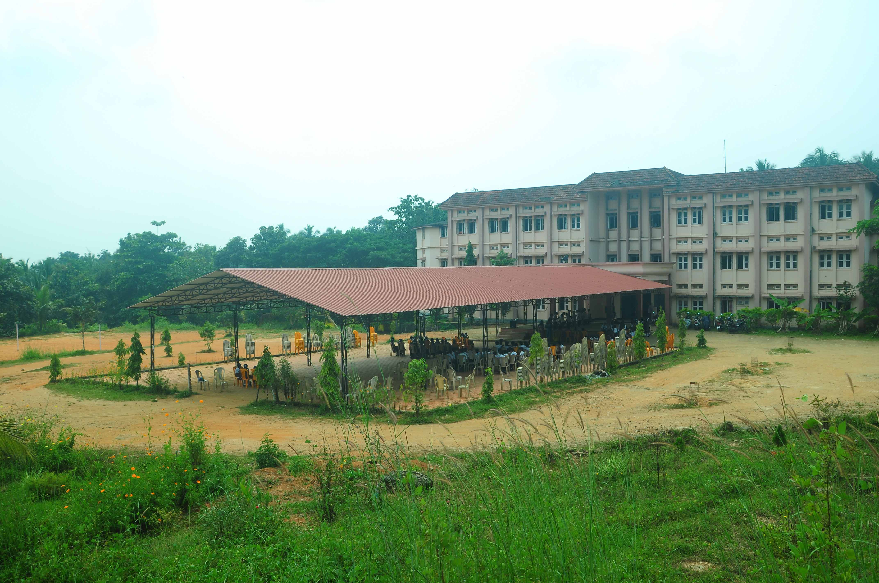
PLAYGROUND PHOTO
LIBRARY PHOTO
SCIENCE LAB PHOTO
PHYSICS LAB PHOTO
CHEMISTRY LAB PHOTO
BIOLOGY LAB PHOTO

